Solutions

3.1 | The pressure is given by the hydrostatic pressure $p(x,z)=ρ_{ice}g\left(H\left(x\right)-z\right),$ which is zero at the surface. | 0.3

3.2a | The outward force on a vertical slice at a distance $x$ from the middle and of a given width $∆y$ is obtained by integrating up the pressure times the area:  $$F\left(x\right)=∆y\int_{0}^{H(x)}{ρ_{ice} g \left(H\left(x\right)-z\right) \text{d}z }=\frac{1}{2} ∆y ρ_{ice} g {H\left(x\right)}^{2}$$  which implies that $∆F=F\left(x\right)-F\left(x+∆x\right)=-\frac{\text{d}F}{\text{d}x}∆x={-∆y ρ}_{ice} g H\left(x\right)\frac{\text{d}H}{\text{d}x}∆x$.  This finally shows that  $$S_{b}=\frac{ΔF}{∆x∆y}=-{ ρ}_{ice} g H\left(x\right)\frac{\text{d}H}{\text{d}x}$$  Notice the sign, which must be like this, since $S_{b}$ was defined as positive and $H\left(x\right)$ is a decreasing function of $x$. | 0.9
3.2b | To find the height profile, we solve the differential equation for $H(x)$:  $$-\frac{S_{b}}{{ ρ}_{ice} g}= H\left(x\right)\frac{\text{d}H}{\text{d}x}=\frac{1}{2}\frac{\text{d}}{\text{d}x}{H\left(x\right)}^{2}$$  with the boundary condition that $H(L)=0$. This gives the solution:  $$H\left(x\right)=\sqrt{\frac{2S_{b}L}{ρ_{ice} g}}\sqrt{1-x/L}$$  Which gives the maximum height $H_{m}=\sqrt{\frac{2S_{b}L}{ρ_{ice} g}}$.  Alternatively, dimensional analysis could be used in the following manner. First notice that $L=\left[H_{m}\right]=\left[ρ_{ice}^{α} g^{β}τ_{b}^{γ}L^{δ} \right]$. Using that $\left[ρ_{ρ_{ice}}\right]=ML^{-3}$, $\left[g\right]=L T^{-2}$, $\left[τ_{b}\right]=ML^{-1} T^{-2}$, demands that $L=\left[H_{m}\right]=\left[{ρ_{i}}^{α}g^{β}{τ_{b}}^{γ}L^{δ}\right]=M^{α+γ}L^{-3α+β-γ+δ} T^{-2β-2γ}$, which again implies $α+γ=0, -3α+β-γ+δ=1, 2β+2γ=0$. These three equations are solved to give $α=β=-γ=δ-1$, which shows that  $$H_{m}∝{\left(\frac{S_{b}}{ρ_{ρ_{ice}}g}\right)}^{γ}L^{1-γ}$$  Since we were informed that $H_{m}∝\sqrt{L}$ , it follows that $γ=1/2$. With the boundary condition $H\left(L\right)=0$, the solution then take the form  $$H(x)∝{\left(\frac{S_{b}}{ρ_{ice} g}\right)}^{1/2}\sqrt{L-x}$$  The proportionality constant of $\sqrt{2}$ cannot be determined in this approach. | 0.8
3.2c | For the rectangular Greenland model, the area is equal to $A=10L^{2}$ and the volume is found by integrating up the height profile found in problem 3.2b:  $V_{G, ice}=\left(5L\right)2\int_{0}^{L}{H\left(x\right) \text{d}x}=10L\int_{0}^{L}{{\left(\frac{τ_{b} L}{ρ_{ice} g}\right)}^{1/2}\sqrt{1-x/L}\text{ d}x}$ $=10H_{m}L^{2}\int_{0}^{1}{\sqrt{1-\tilde{x}}\text{ d}\tilde{x}} =10H_{m}L^{2}{\left[-\frac{2}{3}{\left(1-\tilde{x}\right)}^{3/2}\right]}_{0}^{1}$ $=\frac{20}{3}H_{m}L^{2}∝L^{5/2}$,  where the last line follows from the fact that $H_{m}∝\sqrt{L}$. Note that the integral need not be carried out to find the scaling with $L$. This implies that $V_{G, ice}∝{A_{G}}^{5/4}$ and the wanted exponent is $γ=5/4$. | 0.5

3.3 | According to the assumption of constant accumulation $c$ the total mass accumulation rate from an area of width $∆y$ between the ice divide at $x=0$ and some point at $x>0$ must equal the total mass flux through the corresponding vertical cross section at $x$. That is: $ρcx∆y=ρ∆yH_{m}v_{x}(x),$ from which the velocity is isolated:  $$v_{x}\left(x\right)=\frac{cx}{H_{m}}$$ | 0.6

3.4 | From the given relation of incompressibility it follows that  $$\frac{dv_{z}}{dz}=-\frac{dv_{x}}{dx}=-\frac{c}{H_{m}}$$  Solving this differential equation with the initial condition $v_{z}\left(0\right)=0$, shows that:  $$v_{z}\left(z\right)=-\frac{cz}{H_{m}}$$ | 0.6

3.5 | Solving the two differential equations  $$\frac{dz}{dt}=-\frac{cz}{H_{m}} \text{and} \frac{dx}{dt}=\frac{cx}{H_{m}}$$  with the initial conditions that $z\left(0\right)=H_{m}$, and $x\left(0\right)=x_{i}$ gives  $$z\left(t\right)=H_{m} e^{-ct/H_{m}} \text{and} x(t)=x_{i}{ e}^{ct/H_{m}}$$  This shows that $z=H_{m} x_{i} /x$, meaning that flow lines are hyperbolas in the $xz$-plane.  Rather than solving the differential equations, one can also use them to show that  $$\frac{d}{dt}\left(xz\right)=\frac{dx}{dt}z+x\frac{dz}{dt}=\frac{cx}{H_{m}}z-x\frac{cz}{H_{m}}=0$$  which again implies that $xz=const.$ Fixing the constant by the initial conditions, again leads to the result that $z=H_{m}x_{i}/x$. | 0.9

3.6 | At the ice divide, $x=0$, the flow will be completely vertical, and the $t$-dependence of $z$ found in 3.5 can be inverted to find $τ(z)$. One finds that $τ(z)=\frac{H_{m}}{c}ln⁡\left(\frac{H_{m}}{z}\right)$. | 1.0

3.7a | The present interglacial period extends to a depth of 1492 m, corresponding to 11,700 year. Using the formula for $τ(z)$from problem 3.6, one finds the following accumulation rate for the interglacial:  $$c_{ig}=\frac{H_{m}}{11,700 \text{years}}\ln\left(\frac{H_{m}}{H_{m}-1492 \text{m}}\right)=0.1749 \text{m/year}.$$  The beginning of the ice age 120,000 years ago is identified as the drop in $δ{}_{ }^{18}O$in figure 3.2b at a depth of 3040 m. Using the vertical flow velocity found in problem 3.4, on has $\frac{\text{d}z}{z}=-\frac{c}{H_{m}}\text{d}t$, which can be integrated down to a depth of 3040 m, using a stepwise constant accumulation rate:  $$H_{m}\ln\left(\frac{H_{m}}{H_{m}-3040 \text{m}}\right)={-H}_{m}\int_{H_{m}}^{H_{m}-3040 \text{m}}{\frac{1}{z}}\text{d}z$$  $$=\int_{11,700 \text{year}}^{120,000 \text{year}}{c_{ia}\text{ d}t}+\int_{0}^{11,700 \text{year}}{c_{ig}\text{ d}t} \\ =c_{ia}(120,000 \text{year-}11,700 \text{year)+}c_{ig}11,700 \text{year}$$  Isolating form this equation leads to $c_{ia}=0.1232$, i.e. far less precipitation than now. | 0.8
3.7b | Reading off from figure 3.2b: $δ{}_{ }^{18}O$ changes from $-43,5 ‰$ to $-34,5 ‰$. Reading off from figure 3.2a, $T$ then changes from $-40 ℃$ to $-28 ℃$. This gives $∆T≈12 ℃$. | 0.2

3.8 | From the area $A_{G}$ one finds that $L=\sqrt{A_{G}/10}=4.14×{10}^{5} m$. Inserting numbers in the volume formula found in 3.2c, one finds that:  $$V_{G, ice}=\frac{20}{3}L^{5/2}\sqrt{\frac{2S_{b}}{ρ_{ice}g}}=3.45×{10}^{15} m^{3}$$  This ice volume must be converted to liquid water volume, by equating the total masses, i.e. $V_{G, wa}=V_{G, ice}\frac{ρ_{ice}}{ρ_{wa}}=3.17×{10}^{15} m^{3}$, which is finally converted to a sea level rise, as $h_{G,rise}=\frac{V_{G, wa}}{A_{\text{o}}}=8.79 m$. | 0.6

3.9 | 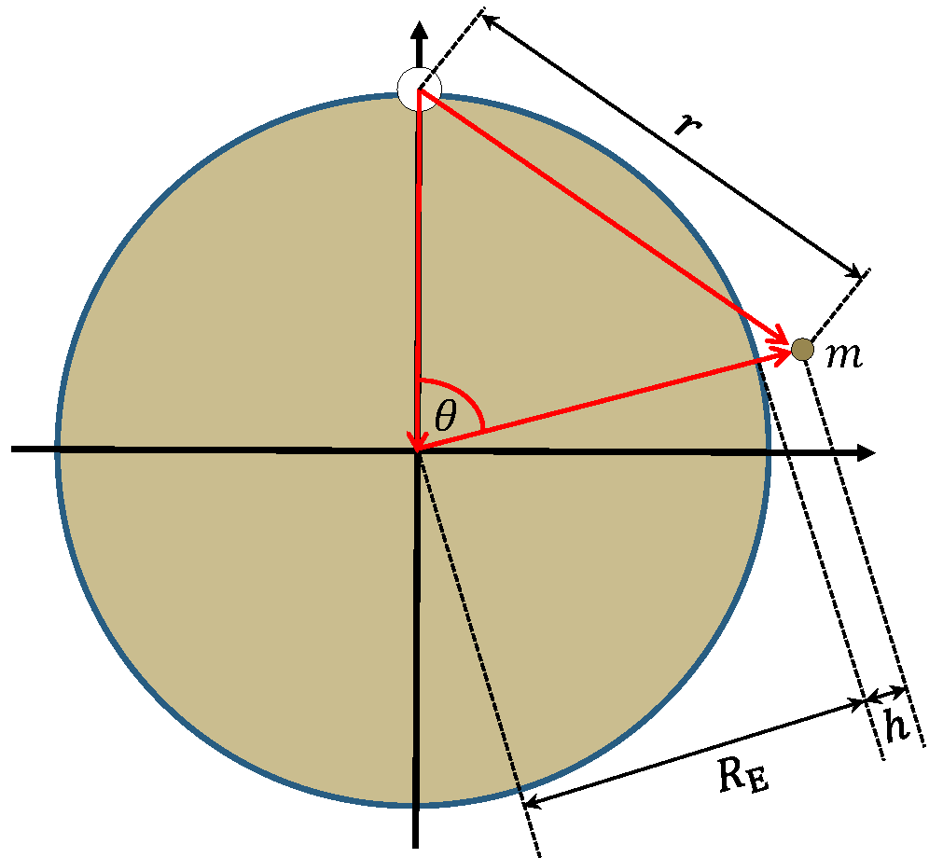  Figure 3.S1 Geometry of the ice ball (white circle) with a test mass $m$ (small gray circle).  The total mass of the ice is  $$M_{ice}=V_{G, ice} ρ_{ice}=3.17×{10}^{18} kg=5.31×{10}^{-7}m_{E}$$  The total gravitational potential felt by a test mass $m$ at a certain height $h$ above the surface of the Earth, and at a polar angle $θ$ (cf. figure 3.S1), with respect to a rotated polar axis going straight through the ice sphere is found by adding that from the Earth with that from the ice:  $$U_{tot}=-\frac{Gm_{E}m}{R_{E}+h}-\frac{GM_{ice}m}{r}=-mgR_{E}\left(\frac{1}{{1+h/R}_{E}}+\frac{M_{ice}/m_{E}}{{r/R}_{E}}\right)$$  where $g=Gm_{E}/R_{E}^{2}$. Since $h/R_{E}≪1$ one may use the approximation given in the problem, ${(1+x)}^{-1}≈1-x, \left|x\right|≪1$, to approximate this by  $$U_{tot}≈-mgR_{E}\left(1-\frac{h}{R_{E}}+\frac{M_{ice}/m_{E}}{{r/R}_{E}}\right).$$  Isolating $h$ now shows that $h=h_{0}+\frac{M_{ice}/m_{E}}{{r/R}_{E}}R_{E}$, where ${h_{0}=R}_{E}+U_{tot}/(mg)$. Using again that $h/R_{E}≪1$, trigonometry shows that $r≈2R_{E}\left|sin(θ/2)\right|$, and one has:  $$h\left(θ\right)-h_{0}≈\frac{M_{ice}/m_{E}}{2\left|sin(θ/2)\right|}R_{E}≈\frac{1.69 \text{m}}{\left|sin(θ/2)\right|}.$$  To find the magnitude of the effect in Copenhagen, the distance of 3500 km along the surface is used to find the angle $θ_{CPH}=(3.5×{10}^{6} \text{m)/}R_{E}≈0.549$, corresponding to $h_{CPH}-h_{0}≈6.25 m.$ Directly opposite to Greenland corresponds to $θ=π$, which gives $h_{OPP}-h_{0}≈1.69 m$. The difference is then $h_{CPH}-h_{OPP}≈4.56 \text{m,}$ where $h_{0}$ has dropped out. | 1.6

 | Total | 9.0

