**Problem 3. Simplest model of gas discharge (10 points)**

An electric current flowing through a gas is called a gas discharge. There are many types of gas discharges including glow discharge in lighting lamps, arc discharge in welding and the well known spark discharge that occurs between the clouds and the earth in the form of lightning.

**Part А. Non-self-sustained gas discharge (4.8 points)**

In this part of the problem the so-called non-self-sustained gas discharge is studied. To maintain it a permanent operation an external ionizer is needed, which creates pairs of singly ionized ions and free electrons per unit volume and per unit time uniformly in the volume.

When an external ionizer is switched on, the number of electrons and ions starts to grow. Unlimited increase in the number densities of electrons and ions in the gas is prevented by the recombination process in which a free electron recombines with an ion to form a neutral atom. The number of recombining events that occurs in the gas per unit volume and per unit time is given by

,

where is a constant called the recombination coefficient, and , denote the electron and ion number densities, respectively.

Suppose that at time the external ionizer is switched on and the initial number densities of electrons and ions in the gas are both equal to zero. Then, the electron number density depends on time as follows:

,

where and are some constants, and stands for the hyperbolic tangent.

|  |  |
| --- | --- |
| **A1** | Find and express them in terms of and . **(1.8 points)** |

Assume that there are two external ionizers available. When the first one is switched on, the electron number density in the gas reaches its equilibrium value of be . When the second external ionizer is switched on, the electron number density reaches its equilibrium value of.

|  |  |
| --- | --- |
| **A2** | Find the electron number density at equilibrium when both external ionizers are switched on simultaneously. **(0.6 points)** |

**Attention!** *In what follows it is assumed that the external ionizer is switched on for quite long period of time such that all processes have become stationary and do not depend on time. Completely neglect the electric field due the charge carriers.*

Assume that the gas fills in the tube between the two parallel conductive plates of area separated by the distance from each other. The voltage is applied across the plates to create an electric field between them. Assume that the number densities of both kinds of charge carriers remain almost constant along the tube.

Assume that both the electrons (denoted by the subscript ) and the ions (denoted by the subscript ) acquire the same ordered speed due to the electric field strength found as

,

where is a constant called charge mobility.

|  |  |
| --- | --- |
| **A3** | Express the electric current in the tube in terms of and which is the elementary charge. **(1.7 points)** |
| **A4** | Find the resistivity of the gas at sufficiently small values of the voltage applied and express it in terms of and . **(0.7 points)** |

**Part B. Self-sustained gas discharge (5.2 points)**

In this part of the problem the ignition of the self-sustained gas discharge is considered to show how the electric current in the tube becomes self-maintaining.

**Attention!** *In the sequel assume that the external ionizer continues to operate with the same* *rate, neglect the electric field due to the charge carriers such that the electric field is uniform along the tube, and the recombination can be completely ignored.*

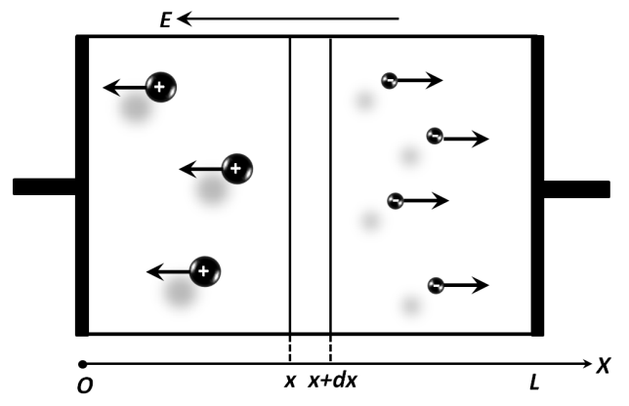For the self-sustained gas discharge there are two important processes not considered above. The first process is a secondary electron emission, and the second one is a formation of electron avalanche. The secondary electron emission occurs when ions hit on the negative electrode, called a cathode, and the electrons are knocked out of it to move towards the positive electrode, called an anode. The ratio of the number of the knocked electrons per unit time to the number of ions hitting the cathode per unit time is called the coefficient of the secondary electron emission, . The formation of the electron avalanche is explained as follows. The electric field accelerates free electrons which acquire enough kinetic energy to ionize the atoms in the gas by hitting them. As a result the number of free electrons moving towards the anode significantly increases. This process is described by the Townsend coefficient, which characterizes an increase in the number of electrons due to moving electrons that have passed the distance , i.e.

.

The total current in any cross section of the gas tube consists of the ion and the electron currents which, in the steady state, depend on the coordinate , shown in the figure above. The electron current varies along the -axis according to the formula

,

where are some constants.

|  |  |
| --- | --- |
| **B1** | Find and express them in terms of . **(2 points)** |

The ion current varies along the -axis according to the formula

,

where are some constants.

|  |  |
| --- | --- |
| **B2** | Find and express them in terms of . **(0.6 points)** |
| **B3** | Write down the condition for at . **(0.3 points)** |
| **B4** | Write down the condition for and at . **(0.6 points)** |
| **B5** | Find the total current and express it in terms of . Assume that it remains finite  **(1.2 points)** |

Let the Townsend coefficient be constant. When the length of the tube turns out greater than some critical value, i.e. , the external ionizer can be turned off and the discharge becomes self-sustained.

|  |  |
| --- | --- |
| **B6** | Find and express it in terms of . **(0.5 points)** |